Journal of Engineering Management and Competitiveness (JEMC) [font Times New Roman, size 11, Bold]

TITLE [FONT Times New Roman, size 14, bold, All caps]

UDC: (Do not enter)
Original Scientific Paper, Review Paper, Short or Preliminary Communication (Select the type of manuscript)

Name and surname of the author [font Times New Roman, size 10, Bold]
Affiliation and Country [font Times New Roman, size 10]
e-mail [font Times New Roman, size 10]
(Please mark the corresponding author with *.)

Received: /Accepted: /Published:

ABSTRACT [FONT TIMES NEW ROMAN SIZE 10, BOLD, ALL CAPS]

Abstract [font Times New Roman, size 10] (200 words max.)

Key words: key word 1,... key word 6 [font Times New Roman, size 10]

HEADING LEVEL 1 [font name Times New Roman, size 11, Bold, All caps]

Journal of Engineering Management and Competitiveness (JEMC) publishes original papers that have not been published previously. In those cases where the paper has been presented at a Conference, it can be published in Journal if it has not been published in generally available conference materials and/or if it has not been published in its entirety.

All submissions must be typed in English, single spaced with 2.5 cm all margins (Top, Bottom, Left and Right), paper size A4, using 11 point Times New Roman font in a single MS Word file. [font Times New Roman, size 11, justified text]. Please ensure that English and style is properly edited before submission. Manuscript with substandard English may not be considered.

Authors from Serbia should supy manuscripts with Title, Abstract, and Keywords on serbian language, utilizing Latin scrip.

All submissions must include a Title, Authors (names, affiliations, e-mails of all authors and a notation (*) of the corresponding author), an Abstract (no more than 200 words) and 3-6 Keywords. Paper usualy should include text body (Introduction, Theory, Methods, Findings, Discussion, Conclusions and Implications), Tables, Figures and References. The Acknowledgments of people, grants, funds, etc should be brief. Footnotes to the text should be avoided wherever this is reasonably possible. No maximum length exists, but authors should write concisely. A significant review element will be the paper's length relative to its content.

The following is an example of a bullet list:
- Do not end headings with full stops.
- Do not start headings at the foot of a page or with only one line of text below.

Following is an example of a numbered list:
- For complete or near complete sentences, begin with a capital letter and end with a full stop.
- For short phrases, start with lower case letters and end with semicolons.
- Do not capitalize or punctuate single items.

To maintain the focus and scope of Journal of Engineering Management and Competitiveness (JEMC), the Editorial encourages authors to identify past articles which have been published in the Journal, fits with the subject area of the manuscript. This helps the Editorial to determine the suitability of the manuscripts to JEMC.

Once the manuscript is accepted for publication, authors shall transfer the copyright to the Publisher. Upon transfer of the copyright to the publisher, no part of the manuscript may be reproduced in any form without written permission of the publisher. If the submitted manuscript is not accepted for publication by the Journal, all rights shall be retained by the Author(s).

Three levels of headings maximum:
- Heading Level 2 [font Times New Roman, size 11, Bold]
- Heading Level 3 [font Times New Roman, size 11, Bold, Italics]

Math formulae

It is recommended to use MS Word program Equations editor to type all formulas. Number equations consecutively. Equation numbers, within parentheses, are to position flush right, as in (1), using a right tab stop. To make your equations more compact, you may use the solidus (/), the exp function, or appropriate exponents. Italicize Roman symbols for quantities and variables, but not Greek symbols. Use a long dash rather than a hyphen for a minus sign. Punctuate equations with commas or periods when they are part of a sentence, as in

$α+β=γ$ 

Note that the equation is centered using a center tab stop. Be sure that the symbols in your equation have been defined before or immediately following the equation.

Tables and Figures

Tables and figures need to be included in the body of the paper. Colour figures will be reproduced in colour only in the online edition of the Journal. Please make references to all tables and figures. Example: This is shown in Table 1. Example: text (see also Figure 1).

Table 1: Title of the table [font Times New Roman, size 11, Italic]
xxx | Table Text [font Times New Roman, size 10]
 | 1 | 2 | 3 | 4
AAA | …
BBB | …

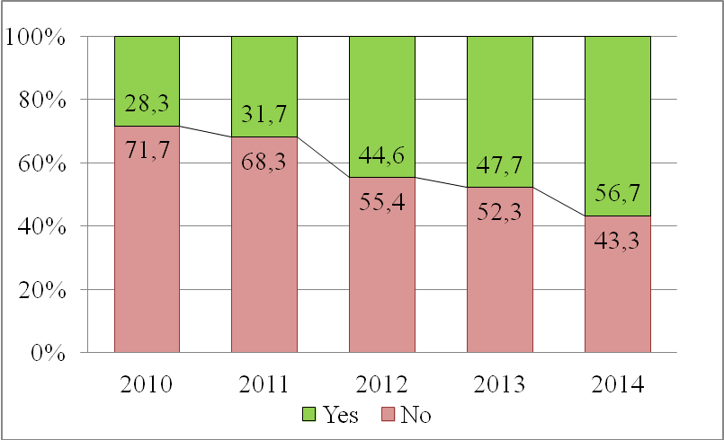
Figure 1: Title of the figure [font Times New Roman, size 11, Italic]

APPENDIX [font Times New Roman, size 11, bold, All caps]

Appendixes, if needed, appear before the acknowledgment.

ACKNOWLEDGEMENT [font Times New Roman, size 11, bold, All caps]

Use the singular heading even you have many acknowledgments. Also put in this section sponsor and financial support acknowledgments.

References [font Times New Roman, size 11, bold, All caps]

Please use last names of authors and the publication year in citations in the text (for three or more authors use et al.). Examples: Managerial issues (including HR issues) need to be considered in the firm growth (Antoncic et al., 2004; Hisrich et al., 2008). Antoncic and Hisrich (2001) examined the intrapreneurship construct and model in two countries. References to Internet materials should be treated as other references in the text. In the reference list, they should be dated and sufficiently identified for readers to be able to find the material unambiguously.

Please ensure that every reference cited in the text is also present in the reference list (and vice versa). Any references cited in the abstract must be given in full. Unpublished results and personal communications are not recommended in the reference list, but may be mentioned in the text. If the reference has not been written in English, please translate it into English, and state the original language in square brackets, e.g. [in Serbian]. References should be listed in alphabetical order according to the last name of the first author in the American Psychological Association (APA) style.

Antoncic, B., & Hisrich, R. D. (2001). Intrapreneurship: Construct refinement and cross-cultural validation. Journal of Business Venturing, 16(5), 495-527.
Antoncic, B., Cardon, M. S., & Hisrich, R. D. (2004). Internationalizing corporate entrepreneurship: The impact on global HR management. In Katz, J. A., & Shepherd D. A. (Eds.), Corporate Entrepreneurship: Advances in Entrepreneurship, Firm Emergence and Growth, Vol. 7. Oxford, UK: Elsevier, JAI, 173-197.
Ćoćkalo, D., Bogetić, S., Đorđević, D., & Bešić, C. (2015). Attitudes of Undergraduate Business Students’ in Serbia Towards CSR and Competitiveness. In V. Majstorović (Ed.), Proceedings of The 8th International Working Conference Total Quality Management - Advancedand Intelligent Approaches (pp. 321-328). Belgrade, Serbia: Mechanical Engineering Faculty.
Đorđević, D., Ćoćkalo, D., Ćeha, M., & Gligorović, B. (2014, 9-10th October 2014). Corporate Social Responsibility and Sustainable Development. Paper presented at the IV International Conference "Ecology of Urban Areas 2014", Zrenjanin, Serbia.
Hisrich, R. D., Peters, M. P., & Shepherd, D. A. (2008). Entrepreneurship. 7th ed. Boston, MA: McGraw-Hill.
Keup, L. C. (2002). A network of working relationships and its influence on individual job outcomes (Unpublished doctoral dissertation or master's thesis). University of Manitoba, Canada.
When citing an entire website, it is sufficient just to give the address of the site in the text. The BBC (http://www.bbc.co.uk)

